Assessment Schedule – 2015
Physics: Demonstrate understanding of aspects of heat (90939)
Assessment Criteria
Achievement | Achievement with Merit | Achievement with Excellence
Demonstrate understanding of aspects of heat involves:  Demonstrating awareness of heat transfer, such as methods and statements of features that minimise heat transfer. | Demonstrate in-depth understanding of aspects of heat involves:  Showing how heat transfer methods can be minimised with certain features. | Demonstrate comprehensive understanding of aspects of heat involves:  Providing evidence that shows how concepts of heat relate to the context of minimising heat transfer within a given context.
Evidence
ONE  (a) | Steel is a (good) conductor of heat.  OR  Heat is lost from his hand to the tank. | Steel is a (good) conductor of heat. When the famer touches the tank with his (hot) hand, heat is conducted from his hand to the tank/absorbed by the tank, hence the hand feels cold. (There must be a statement or a clear implication that the heat is going from hot to cold).
(b) | The heat energy from the Sun reaches the tank by radiation.  AND  The metal body of the tank absorbs heat and then it is transferred by conduction within the metal body of the tank.
(c) | Correct working and answer in joules.  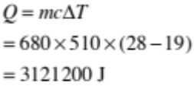  OR  Correct workings but incorrect calculation, e.g. 312.1 (kJ) | Correct working and answer in kilojoules.  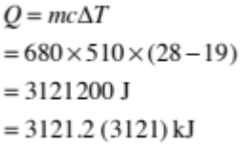
(d) | Describes any O NE of:  White coloured cover reflects light / White coloured cover is a poor absorber of light.  OR  The trapped air is a poor conductor of heat  OR  The stainless steel is a good reflector of heat. | Explains any ONE of:  - White cover reflects most of the radiation / is a poor absorber of radiation that would otherwise transferred to the milk / tank.  - The trapped air is a poor conductor, so heat transfer minimised  - The polished stainless steel surface reflects most of the radiation/ is a poor absorber of radiation that would otherwise transferred to the milk/tank. | Explains that:  (2/3 = E7, 3/3 =E8)  - The white cover is a good reflector of radiant energy / is a poor absorber of radiant energy and it reflects radiant energy. The milk doesn’t get heated as much by the radiant energy.  - Trapped air is a poor conductor / good insulator of heat energy AND since pockets of air are isolated, there is no heat transferred by convection.  - The polished stainless steel surface is a good reflector of radiant energy / is a poor absorber of radiant energy and it reflects any radiant energy that has passed through the insulating material.

NØ | N1 | N2 | A3 | A4 | M5 | M6 | E7 | E8
No response; no relevant evidence. | Very little Achievement evidence. | Some evidence at the Achievement level; partial explanations. | Most evidence is at the Achievement level. | Nearly all the evidence is at the Achievement level. | Some evidence is at the Merit level with the remainder at the Achievement level. | Most evidence is at the Merit level with some at the Achievement level. | Evidence is provided for most tasks with evidence at the Excellence level weak or incomplete. | Evidence is provided for most tasks with evidence at the Excellence level accurate and full.
As above. | 1a | 2a | 3a  OR  1e + 1a  OR  1m + 1a | 4a | 2m  OR  1e + 2a  OR  1e + 1m | 3m | 1a + 1m  AND  Any two aspects of task 1(d) explained. | 1a + 1m  AND  All three aspects of task 1(d) explained.

Q | Achievement | Achievement with Merit | Achievement with Excellence
TWO  (a) | 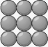  Both of:  (i) A diagram showing a regular arrangement of particles where the particles are almost touching / touching.  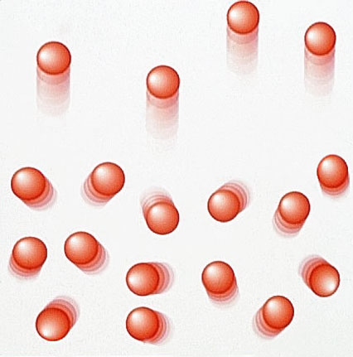  (ii) A diagram showing randomly moving particles / very widely spaced particles.
(b) | Mentions conduction as the heat transfer method.  OR  States the vibration of particles causes heat transfer. | Heat is transferred by conduction from Box B to Box A. Heat from the steam causes the particles in metal box B to vibrate (more). Since the sides of boxes are in contact, the particles in the metal box A begin to vibrate, thereby transferring heat energy. | Heat is transferred by conduction from Box B to Box A. Heat from the steam causes the particles in metal box B to vibrate (more). Since the sides of boxes are in contact, the particles in the metal box A begin to vibrate.  AND  Metal box A conducts the heat to milk / heat energy is transferred to the milk by convection.
(c) | The distance between the particles increases. | The distance between the particles increases because when the particles gain heat, they begin to vibrate more / quicker, causing more space between particles.

(d)(i) | Correct working for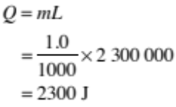  OR | Correct working  AND | Correct working  AND
(ii) | Calculated  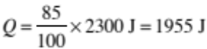  OR  ∆T correctly from incorrectly calculated value of Q | Correct working and answer for energy transferred to the milk:  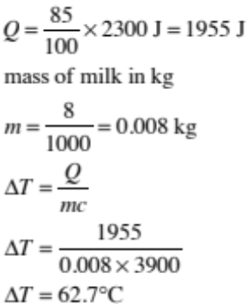 | Correct working and answer for energy transferred to the milk:
(iii) |  | (Correct SI units required. Final answer of 62.6602564 can be to any number of s.f., but must be correctly rounded.) | (Correct SI units required. Final answer of 62.6602564 can be to any number of s.f., but must be correctly rounded.)  AND  The heat energy is lost to the surroundings by convection. The plate conducts heat to the air near the plate gets hot and hot air rises, creating convection current.  OR  Heat is lost by radiation. The hot plates are hotter than the surroundings. The hot metal plates radiate heat energy to the surroundings.  OR  Heat lost by conduction. The hot metal particles vibrate and collide with the nearby air particles. Air particles in contact with metal plates conduct heat away from the plates.

NØ | N1 | N2 | A3 | A4 | M5 | M6 | E7 | E8
No response; no relevant evidence. | Very little Achievement evidence. | Some evidence at the Achievement level; partial explanations. | Most evidence is at the Achievement level. | Nearly all the evidence is at the Achievement level. | Some evidence is at the Merit level with the remainder at the Achievement level. | Most evidence is at the Merit level with some at the Achievement level. | Evidence is provided for most tasks with evidence at the Excellence level weak or incomplete. | Evidence is provided for most tasks with evidence at the Excellence level accurate and full.
As above. | 1a | 2a | 3a  OR  1e + 1a  OR  1m + 1a | 4a | 2m  OR  1e + 2a  OR  1e + 1m | 3m | 1a + 1m  AND  1e | 1a + 1m  AND  2e

Q | Achievement | Achievement with Merit | Achievement with Excellence
THREE  (a) | 2300 000 J of energy is given out when 1 kg of steam condenses into water  OR | 2300 000 J of energy is given out when 1 kg of steam condenses into water without a change in temperature.  OR
 | 2300 000 J of energy is required when 1 kg of water is turned into steam.  OR | 2 300 000 J of energy per kg of is required when water is turned into steam without a change in temperature.  OR
 | 2300 000 J of energy is given out when 1 kg of water freezes into ice.  OR  2300 000 J of energy is required when 1 kg of ice melts into water.  OR  2300 000 J of energy is required when 1 kg of water changes state. | 2300 000 J of energy is given out when 1 kg of water freezes into ice without a change in temperature.  OR  2300 000 J of energy is required when 1 kg of ice melts into water without a change in temperature.  OR  2300 000 J of energy is required when 1 kg of water changes state without a change in temperature.
(b) | One of:  - convection  - radiation  - conduction  - evaporation  - condensation  is used to explain the heat transfer method. | The lid reduces heat loss by convection from the hot coffee to the surrounding by enclosing the air space above the coffee.  OR  The lid reduces heat loss by radiation from the hot coffee by limiting the space above the coffee to the surrounding OR reflecting some heat back to the coffee.  OR  The lid reduces heat loss by conduction from the hot coffee by trapping air and the air is a poor conductor / good insulator.  OR  The lid reduces heat loss by evaporation; otherwise the (moving) air would take heat energy from the coffee cooling the coffee down.
(c)(i) | Calculated Q  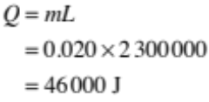  OR  correct t calculated from incorrectly calculated value of Q. | Correct calculation:  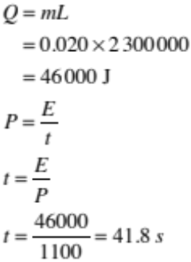  (Correct SI units required – not “secs”. Final answer of 41.81818 can be to any number of s.f but must be correctly rounded.) | Correct calculation:  (Correct SI units required – not “secs”. Final answer of 41.81818 can be to any number of s.f but must be correctly rounded.)
(ii) | OR  States that steam has more energy than boiling water. | OR  Steam has more energy than water. This is because the energy is added to the boiling water to separate the water molecules further apart (break the bond between water molecules) to convert into steam or vapour.  OR  the steam has gained / absorbed latent heat | AND  Steam has more energy than water. This is because the energy is added to the boiling water to separate the water molecules further apart (break the bond between water molecules) to convert into steam or vapour.  OR  the steam has gained / absorbed latent heat

(d)(i) | 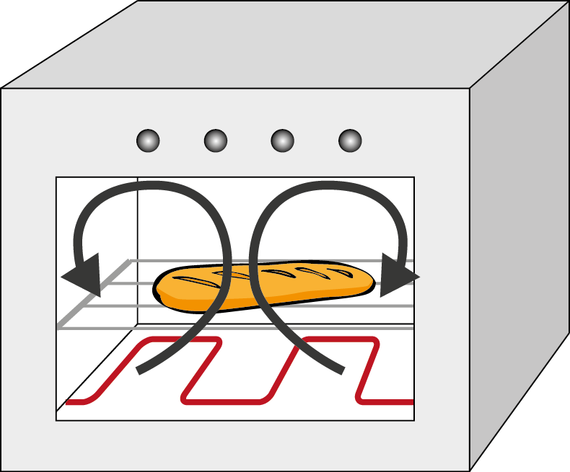  Drawn at least one upward arrow and one downward arrow showing the direction of convection current.  OR | Drawn at least one upward arrow and one downward arrow showing the direction of convection current.  AND | Drawn at least one upward arrow and one downward arrow showing the direction of convection current.  AND
(ii) | The hot air near to the element expands, the hot air becomes less dense and it starts to rise upwards.  OR  The less dense solid air at the top cools and sinks to the bottom, thus causing a convection current inside the oven.  (Do not accept: Particles less dense.) | The hot air near to the element expands, the hot air becomes less dense and it starts to rise upwards.  AND  The less dense solid air at the top cools and sinks to the bottom, thus causing a convection current inside the oven  (Do not accept: Particles less dense.) | The hot air near to the element expands, the hot air becomes less dense and it starts to rise upwards. The less dense solid air at the top sinks to the bottom, thus causing a convection current inside the oven.  (Do not accept: Particles less dense.)  AND  The process repeats itself / recycles.

NØ | N1 | N2 | A3 | A4 | M5 | M6 | E7 | E8
No response; no relevant evidence. | Very little Achievement evidence. | Some evidence at the Achievement level; partial explanations. | Most evidence is at the Achievement level. | Nearly all the evidence is at the Achievement level. | Some evidence is at the Merit level with the remainder at the Achievement level. | Most evidence is at the Merit level with some at the Achievement level. | Evidence is provided for most tasks with evidence at the Excellence level weak or incomplete. | Evidence is provided for most tasks with evidence at the Excellence level accurate and full.
As above. | 1a | 2a | 3a  OR  1e + 1a  OR  1m + 1a | 4a | 2m  OR  1e + 2a  OR  1e + 1m | 3m | 1a + 1m  AND  1e | 1a + 1m  AND  2e

Cut Scores
Not Achieved | Achievement | Achievement with Merit | Achievement with Excellence
0 – 7 | 8 – 13 | 14 – 18 | 19 – 24

